Министерство образования и молодежной политики Свердловской области



ГАПОУ СО «Екатеринбургский колледж транспортного строительства»

Отчёт по программе «Практическое занятие 22_2

Сетевые взаимодействия - работа с API.»

Выполнил: Оберюхтина Елена

Группа: ПР-31

Преподаватель: Мирошниченко Г. В.

2023

**Цель:**

1. Научиться работать API
2. Повторить работу с форматом данных JSON и базой ROOM на языке Kotlin.

**Задание (вариант 2 – Приложение «Факты о персонаже» Poke API ( https://pokeapi.co/ ). Персонаж выбирается по его имени или id пользователем приложения.):**

Разработать мобильное приложение, информация в приложении должна быть запрошена через API и сохраняться в room.

Приложение должно содержать:

* приветственный экран с авторизацией пользователя, проверкой;
* ввода на пустоту и сохранением информации о пользователе через механизм SharedPreferences;
* содержать форму ввода данных;
* экран для вывода сохраненной информации, с использованием библиотеки ROOM, возможностью добавления, удаления и редактирования введенных данных, с сохранением в базе данных (ROOM или SQL);
* стилизация приложения в соответствии с вариантом;
* изменить название, тему и иконку приложения (должны соответствовать названию);
* предусмотреть портретную ориентацию

**Входные данные:**

* username (String) – введенный пользователем логин;
* password (String) – введенный пользователем пароль;
* pocemon (String) – введенный пользователем цифра для факта.

**Выходные данные:**

* InfoSet, в котором отображаются вся информация;
* Сообщения пользователю об ошибках.

**Листинг программы:**

Dao

package com.example.pract22_2  
  
import androidx.room.*  
import androidx.room.Dao  
import kotlinx.coroutines.flow.Flow  
  
@Dao  
interface Dao {  
 //запись  
 @Insert  
 fun insertItem(item: Item)  
  
 //получение всей бд  
 @Query("SELECT * FROM items")  
 fun getAllItem(): Flow<List<Item>>  
 //удаление  
 @Delete  
 suspend fun deleteItem(item: Item)  
 //обновление  
 @Update  
 suspend fun updateItem(item: Item)  
}

Item

package com.example.pract22_2  
import androidx.room.ColumnInfo  
import androidx.room.Entity  
import androidx.room.PrimaryKey  
  
@Entity (tableName = "items")  
  
//коллоны  
data class Item(  
  
 //ид  
 @PrimaryKey(autoGenerate = true)  
 var id: Int? = null,  
 //имя  
 @ColumnInfo(name = "name")  
 var name: String,  
 //рост  
 @ColumnInfo(name = "height")  
 var height: String,  
 //вес  
 @ColumnInfo(name = "weight ")  
 var weight: String,  
 //способность  
 @ColumnInfo(name = "ability")  
 var abiliti: String,  
  
 )

ItemAdapter

package com.example.pract22_2  
  
import android.content.Context  
import android.view.LayoutInflater  
import android.view.View  
import android.view.ViewGroup  
import android.widget.BaseAdapter  
import android.widget.ImageButton  
import android.widget.TextView  
  
class ItemAdapter(  
 context: Context,  
 private val itemList: List<Item>,  
 private val onDeleteClick: (Item) -> Unit,  
 private val onEditClick: (Item) -> Unit  
) : BaseAdapter() {  
 private val inflater: LayoutInflater = LayoutInflater.from(context)  
  
 override fun getCount(): Int {  
 return itemList.size  
 }  
  
 override fun getItem(position: Int): Any {  
 return itemList[position]  
 }  
  
 override fun getItemId(position: Int): Long {  
 return position.toLong()  
 }  
  
 override fun getView(position: Int, convertView: View?, parent: ViewGroup?): View {  
 val view: View  
 val holder: ViewHolder  
  
 if (convertView == null) {  
 view = inflater.inflate(R.layout.*activity_item_list_row*, parent, false)  
 holder = ViewHolder(  
 view.findViewById(R.id.*titleTextView*),  
 view.findViewById(R.id.*descriptionTextView*),  
 view.findViewById(R.id.*editButton*),  
 view.findViewById(R.id.*deleteButton*),  
 view.findViewById(R.id.*weightText*),  
 view.findViewById(R.id.*abilityText*)  
 )  
 view.*tag* = holder  
 } else {  
 view = convertView  
 holder = view.*tag* as ViewHolder  
 }  
  
 val item = itemList[position]  
 holder.titleTextView.*text* = item.name  
 holder.descriptionTextView.*text* = item.height  
 holder.weightText.*text* = item.weight  
 holder.abilityText.*text* = item.abiliti  
  
 // Обработка нажатий на кнопку "Редактировать"  
 holder.editButton.setOnClickListener **{** onEditClick(item)  
 **}** // Обработка нажатий на кнопку "Удалить"  
 holder.deleteButton.setOnClickListener **{** onDeleteClick(item)  
 **}** return view  
 }  
  
 private class ViewHolder(  
 val titleTextView: TextView,  
 val descriptionTextView: TextView,  
 val editButton: ImageButton,  
 val deleteButton: ImageButton,  
 val weightText: TextView,  
 val abilityText: TextView  
 )  
}

Item_list_row

package com.example.pract22_2  
  
import androidx.appcompat.app.AppCompatActivity  
import android.os.Bundle  
  
class item_list_row : AppCompatActivity() {  
 override fun onCreate(savedInstanceState: Bundle?) {  
 super.onCreate(savedInstanceState)  
 setContentView(R.layout.*activity_item_list_row*)  
 }  
}

MainActivity

package com.example.pract22_2  
  
import android.content.Context  
import android.content.Intent  
import android.content.SharedPreferences  
import androidx.appcompat.app.AppCompatActivity  
import android.os.Bundle  
import android.widget.Button  
import android.widget.EditText  
import android.widget.Toast  
import androidx.appcompat.app.AlertDialog  
  
class MainActivity : AppCompatActivity() {  
 private lateinit var usernameEditText: EditText  
 private lateinit var passwordEditText: EditText  
 private lateinit var sharedPreferences: SharedPreferences  
 override fun onCreate(savedInstanceState: Bundle?) {  
 super.onCreate(savedInstanceState)  
 setContentView(R.layout.*activity_main*)  
 val registerButton = findViewById<Button>(R.id.*registrbut*)  
 registerButton.setOnClickListener **{** val intent = Intent(this, RegistrActivity::class.*java*)  
 startActivity(intent)  
 finish()  
 **}** usernameEditText = findViewById(R.id.*login*)  
 passwordEditText = findViewById(R.id.*pass*)  
 val loginButton: Button = findViewById(R.id.*enterbut*)  
 sharedPreferences = getSharedPreferences("my_app_prefs", Context.*MODE_PRIVATE*)  
 val savedUsername = sharedPreferences.getString("login", "")  
 val savedPassword = sharedPreferences.getString("password", "")  
 // установка сохраненного имя пользователя в EditText  
 usernameEditText.setText(savedUsername)  
  
 loginButton.setOnClickListener **{** val username = usernameEditText.*text*.toString().*trim*()  
 val password = passwordEditText.*text*.toString().*trim*()  
  
 if (username.*isEmpty*()) {  
 Toast.makeText(this@MainActivity, "Введите логин", Toast.*LENGTH_SHORT*).show()  
 if (password.*isEmpty*()) {  
 Toast.makeText(this@MainActivity, "Введите пароль", Toast.*LENGTH_SHORT*).show()  
 }  
 }  
 if (password.*isEmpty*()) {  
 Toast.makeText(this@MainActivity, "Введите пароль", Toast.*LENGTH_SHORT*).show()  
 }  
  
 if (savedUsername == username && savedPassword == password) {  
 val intent = Intent(this, PokemonActivity::class.*java*)  
 intent.putExtra("saved_username", username)  
 startActivity(intent)  
 finish()  
 } else {  
 val alertDialogBuilder = AlertDialog.Builder(this)  
 alertDialogBuilder.setTitle("Ошибка")  
 alertDialogBuilder.setMessage("Неверный логин или пароль.")  
 alertDialogBuilder.setPositiveButton("OK") **{** _, _ **-> }** val alertDialog = alertDialogBuilder.create()  
 alertDialog.show()  
 }  
 **}** }  
}

MainDb

package com.example.pract22_2  
  
import android.content.Context  
import androidx.room.Database  
import androidx.room.Room  
import androidx.room.RoomDatabase  
  
  
@Database(entities = [Item::class], version = 1)  
abstract class MainDb : RoomDatabase() {  
  
 abstract fun getDao(): Dao  
  
 companion object{  
 fun getDb(context: Context): MainDb{  
 return Room.databaseBuilder(  
 context.*applicationContext*, MainDb::class.*java*, "test.db"  
 ).build()  
 }  
 }  
}

PokemonActivity

package com.example.pract22_2  
  
import android.content.Intent  
import androidx.appcompat.app.AppCompatActivity  
import android.os.Bundle  
import android.util.Log  
import android.view.View  
import android.widget.EditText  
import android.widget.TextView  
import android.widget.Toast  
import androidx.appcompat.app.AlertDialog  
import com.android.volley.Request  
import com.android.volley.toolbox.StringRequest  
import com.android.volley.toolbox.Volley  
import org.json.JSONException  
import org.json.JSONObject  
  
class PokemonActivity : AppCompatActivity() {  
 override fun onCreate(savedInstanceState: Bundle?) {  
 super.onCreate(savedInstanceState)  
 setContentView(R.layout.*activity_pokemon*)  
 }  
 private fun getResualt(poce:String)  
 {  
 if (poce.*isNotEmpty*()) {  
 val url = "https://pokeapi.co/api/v2/pokemon/${poce}/"  
  
 val queue = Volley.newRequestQueue(this)  
  
 val stringRequest = StringRequest(  
 Request.Method.*GET*, url,  
 **{** response **->** try {  
 val jsonObject = JSONObject(response)  
 val name = jsonObject.getString("name")  
 val height = jsonObject.getInt("height")  
 val weight = jsonObject.getInt("weight")  
 val abilities = jsonObject.getJSONArray("abilities")  
 val abilityList = *mutableListOf*<String>()  
 for (i in 0 *until* abilities.length()) {  
 val abilityObject = abilities.getJSONObject(i)  
 val ability = abilityObject.getJSONObject("ability")  
 val abilityName = ability.getString("name")  
 abilityList.add(abilityName)  
 }  
 Log.d("MyLog", "Name: $name")  
 Log.d("MyLog", "Height: $height")  
 Log.d("MyLog", "Weight: $weight")  
 Log.d("MyLog", "Abilities: ${abilityList.*joinToString*(", ")}")  
  
 val textInfoSet: TextView = findViewById(R.id.*textinfo*)  
 textInfoSet.*text* =  
 "Name: $name\nHeight: $height\nWeight: $weight\nAbilities: ${  
 abilityList.*joinToString*(", ")  
 }"  
 //запись в бд  
 val db = MainDb.getDb(this)  
 val item = Item(  
 null,  
 name,  
 height.toString(),  
 weight.toString(),  
 abilityList.*joinToString*()  
 )  
 Thread **{** db.getDao().insertItem(item)  
 **}**.start()  
  
 } catch (e: JSONException) {  
 Log.e("MyLog", "JSON Parsing error: ${e.message}")  
 }  
 **}**,  
 **{** error **->** Log.d("MyLog", "Volley error: ${error.message}")  
 **}**)  
  
 queue.add(stringRequest)  
 }  
 else{ Toast.makeText(this@PokemonActivity, "Заполните поле", Toast.*LENGTH_SHORT*).show()  
 }  
 }  
 fun getResultBut(view: View) {  
 val findpocemon: EditText =findViewById(R.id.*editText*)  
 val pocemon = findpocemon.*text*.toString()  
  
 getResualt(pocemon)  
 }  
 fun perehod(view: View) {  
 val intent = Intent(this, ScreenStatistics::class.*java*)  
 startActivity(intent)  
 }  
}

RegistrActivity

package com.example.pract22_2  
  
import android.app.AlertDialog  
import android.content.Context  
import android.content.Intent  
import android.content.SharedPreferences  
import androidx.appcompat.app.AppCompatActivity  
import android.os.Bundle  
import android.view.View  
import android.widget.Button  
import android.widget.EditText  
import android.widget.Toast  
  
class RegistrActivity : AppCompatActivity() {  
  
 private lateinit var sharedPreferences: SharedPreferences  
 override fun onCreate(savedInstanceState: Bundle?) {  
 super.onCreate(savedInstanceState)  
 setContentView(R.layout.*activity_registr*)  
 val toRegisterButton = findViewById<Button>(R.id.*registrbutone*)  
 sharedPreferences = getSharedPreferences("my_app_prefs", Context.*MODE_PRIVATE*)  
 toRegisterButton.setOnClickListener **{** val loginTextView = findViewById<EditText>(R.id.*login1*)  
 val passwordTextView = findViewById<EditText>(R.id.*pass1*)  
  
 val username = loginTextView.*text*.toString().*trim*()  
 val password = passwordTextView.*text*.toString().*trim*()  
  
 if (username.*isEmpty*()) {  
 Toast.makeText(this@RegistrActivity, "Введите логин", Toast.*LENGTH_SHORT*).show()  
 if (password.*isEmpty*()) {  
 Toast.makeText(this@RegistrActivity, "Введите пароль", Toast.*LENGTH_SHORT*).show()  
 }  
 }  
 if (password.*isEmpty*()) {  
 Toast.makeText(this@RegistrActivity, "Введите пароль", Toast.*LENGTH_SHORT*).show()  
 }  
 else{ // сохранение имя пользователя и пароля в SharedPreferences  
 sharedPreferences.edit().putString("login", username).apply()  
 sharedPreferences.edit().putString("password", password).apply()  
  
 val alertDialogBuilder = AlertDialog.Builder(this)  
 alertDialogBuilder.setTitle("Регистрация завершена")  
 alertDialogBuilder.setMessage("Вы успешно зарегистрировались.")  
 alertDialogBuilder.setPositiveButton("OK") **{** _, _ **->** val intent = Intent(this, MainActivity::class.*java*)  
 startActivity(intent)  
 finish()  
 **}** val alertDialog = alertDialogBuilder.create()  
 alertDialog.show()}  
  
 **}** }  
  
 fun btback(view: View) {  
 val intent = Intent(this, MainActivity::class.*java*)  
 startActivity(intent)  
  
 }

ScreenStatistics

package com.example.pract22_2  
  
import android.app.AlertDialog  
import android.content.Intent  
import androidx.appcompat.app.AppCompatActivity  
import android.os.Bundle  
import android.view.View  
import android.widget.EditText  
import android.widget.LinearLayout  
import android.widget.ListView  
import androidx.lifecycle.asLiveData  
import kotlinx.coroutines.CoroutineScope  
import kotlinx.coroutines.Dispatchers  
import kotlinx.coroutines.launch  
import kotlinx.coroutines.withContext  
  
class ScreenStatistics : AppCompatActivity() {  
  
 private val dataList = *mutableListOf*<Item>()  
  
 override fun onCreate(savedInstanceState: Bundle?) {  
 super.onCreate(savedInstanceState)  
 setContentView(R.layout.*activity_screen_statistics*)  
 printInfo()  
 }  
 private fun printInfo() {  
 val textList = findViewById<ListView>(R.id.*listView*)  
 dataList.clear()  
 val db = MainDb.getDb(this)  
 db.getDao().getAllItem().*asLiveData*().observe(this) **{** list **->** val updatedDataList = *mutableListOf*<Item>()  
 list.*forEach* **{** item **->** val newItem = Item(id = item.id, name = item.name, height = item.height, weight = item.weight, abiliti = item.abiliti)  
 updatedDataList.add(newItem)  
 **}** // После завершения цикла, обновите dataList  
 dataList.clear()  
 dataList.addAll(updatedDataList)  
 val itemAdapter = ItemAdapter(this, dataList,  
 onDeleteClick = **{** itemToDelete **->** // Здесь выполняйте удаление элемента из базы данных и обновление списка  
 val db = MainDb.getDb(this)  
 *CoroutineScope*(Dispatchers.IO).*launch* **{** try {  
 db.getDao().deleteItem(itemToDelete)  
  
 printInfo()  
 } catch (e: Exception) {  
 }  
 **}** printInfo()  
 printInfo()  
 **}**,  
 onEditClick = **{** position **->** val db = MainDb.getDb(this)  
 var bdNewText: Array<String> = *arrayOf*("id", "name", "height", "weight", "ability")  
 *CoroutineScope*(Dispatchers.IO).*launch* **{** try {  
 bdNewText= *arrayOf*(position.id.*toString*(), position.name, position.height, position.weight, position.abiliti)  
 } catch (e: Exception) {  
 }  
 **}** //изменения через AlertDiolog  
 val builder = AlertDialog.Builder(this)  
 builder.setTitle("Измените данные")  
 // Создайте контейнер LinearLayout для размещения EditText  
 val layout = LinearLayout(this)  
 val EditNumber = EditText(this)  
 val EditFakt = EditText(this)  
 val EditWeight = EditText(this)  
 val EditAbility = EditText(this)  
 EditNumber.*hint* = "Введите имя покемона"  
 EditFakt.*hint* = "Введите рост"  
 EditWeight.*hint* = "Введите вес"  
 EditAbility.*hint* = "Введите способности"  
 EditNumber.setText(bdNewText[1])  
 EditFakt.setText(bdNewText[2])  
 EditWeight.setText(bdNewText[3])  
 EditAbility.setText(bdNewText[4])  
 layout.addView(EditNumber)  
 layout.addView(EditFakt)  
 layout.addView(EditWeight)  
 layout.addView(EditAbility)  
 builder.setView(layout)  
 builder.setPositiveButton("OK") **{** dialog, _ **->** var number = EditNumber.*text*.toString()  
 var height = EditFakt.*text*.toString()  
 var weight = EditWeight.*text*.toString()  
 var ability = EditAbility.*text*.toString()  
 //запись в бд  
 //проверка  
 if(number.*isEmpty*()){  
 number = bdNewText[1];  
 }  
 if(height.*isEmpty*()){  
 height = bdNewText[2];  
 }  
 if(weight.*isEmpty*()){  
 weight = bdNewText[3];  
 }  
 if(ability.*isEmpty*()){  
 ability = bdNewText[4];  
 }  
 val item = Item(bdNewText[0].*toInt*(), number, height, weight, ability)  
 *CoroutineScope*(Dispatchers.IO).*launch* **{** db.getDao().updateItem(item)  
 **}** printInfo()  
 **}** builder.setNegativeButton("Отмена") **{** dialog, _ **->** dialog.cancel()  
 **}** val dialog = builder.create()  
 dialog.show()  
 printInfo()  
  
 **}**)  
 textList.*adapter* = itemAdapter  
 itemAdapter.notifyDataSetChanged()  
  
 **}** }  
  
 fun ButCleaAll(view: View) {  
 val db = MainDb.getDb(this)  
 *CoroutineScope*(Dispatchers.IO).*launch* **{** // Очистить все таблицы в базе данных  
 db.clearAllTables()  
 withContext(Dispatchers.Main) **{  
 }  
 }** printInfo()  
 }  
 fun AddNewButton(view: View) {  
 val builder = AlertDialog.Builder(this)  
 builder.setTitle("Введите данные")  
 val layout = LinearLayout(this)  
 layout.*orientation* = LinearLayout.*VERTICAL* val EditNumber = EditText(this)  
 val EditFakt = EditText(this)  
 val EditWeight = EditText(this)  
 val EditAbility = EditText(this)  
 EditNumber.*hint* = "Введите имя покемона"  
 EditFakt.*hint* = "Введите рост"  
 EditWeight.*hint* = "Введите вес"  
 EditAbility.*hint* = "Введите способности"  
 layout.addView(EditNumber)  
 layout.addView(EditFakt)  
 layout.addView(EditWeight)  
 layout.addView(EditAbility)  
 builder.setView(layout)  
 builder.setPositiveButton("OK") **{** dialog, _ **->** val number = EditNumber.*text*.toString()  
 val height = EditFakt.*text*.toString()  
 val weight = EditWeight.*text*.toString()  
 val ability = EditAbility.*text*.toString()  
 if(number.*isEmpty*() || height.*isEmpty*() || weight.*isEmpty*() || ability.*isEmpty*()){  
 val builder = AlertDialog.Builder(this)  
 builder.setTitle("Не сохранено")  
 .setMessage("Необходимо заполнить все поля")  
 .setPositiveButton("ОК") **{** dialog, id **->** dialog.cancel()  
 **}** builder.create()  
 builder.show()  
 }  
 else{  
 val db = MainDb.getDb(this)  
 val item = Item(null, number, weight, height, ability)  
 Thread**{** db.getDao().insertItem(item)  
 **}**.start()  
 dialog.dismiss()  
 printInfo()  
 }  
 **}** builder.setNegativeButton("Отмена") **{** dialog, _ **->** dialog.cancel()  
 **}** val dialog = builder.create()  
 dialog.show()  
 }  
 fun ButBack(view: View) {  
 val intent = Intent(this, PokemonActivity::class.*java*)  
 startActivity(intent)  
 }  
  
  
}

activity_item_list_row

<?xml version="1.0" encoding="utf-8"?>  
<LinearLayout  
 xmlns:android="http://schemas.android.com/apk/res/android"  
 xmlns:app="http://schemas.android.com/apk/res-auto"  
 xmlns:tools="http://schemas.android.com/tools"  
 android:layout_width="match_parent"  
 android:layout_height="match_parent"  
 tools:context=".item_list_row">  
 <LinearLayout  
 android:layout_width="300dp"  
 android:layout_height="wrap_content"  
 android:orientation="vertical">  
 <TextView  
 android:textColor="@color/black"  
 android:id="@+id/titleTextView"  
 android:layout_width="match_parent"  
 android:layout_height="wrap_content"  
 android:textSize="18sp"  
 android:textStyle="bold"  
 android:paddingStart="16dp"  
 android:paddingTop="8dp"  
 android:paddingEnd="16dp"  
 android:paddingBottom="4dp" />  
 <LinearLayout  
 android:layout_width="wrap_content"  
 android:layout_height="wrap_content"  
 android:orientation="horizontal">  
 <TextView  
 android:textColor="@color/black"  
 android:text="Рост:"  
 android:textSize="14sp"  
 android:paddingStart="16dp"  
 android:paddingTop="4dp"  
 android:paddingEnd="16dp"  
 android:paddingBottom="8dp"  
 android:layout_width="100dp"  
 android:layout_height="wrap_content"></TextView>  
 <TextView  
 android:textColor="@color/black"  
 android:id="@+id/descriptionTextView"  
 android:layout_width="match_parent"  
 android:layout_height="wrap_content"  
 android:textSize="14sp"  
 android:paddingStart="16dp"  
 android:paddingTop="4dp"  
 android:paddingEnd="16dp"  
 android:paddingBottom="8dp" />  
  
 </LinearLayout>  
 <LinearLayout  
 android:layout_width="wrap_content"  
 android:layout_height="wrap_content"  
 android:orientation="horizontal">  
 <TextView  
 android:textColor="@color/black"  
 android:text="Вес:"  
 android:textSize="14sp"  
 android:paddingStart="16dp"  
 android:paddingTop="4dp"  
 android:paddingEnd="16dp"  
 android:paddingBottom="8dp"  
 android:layout_width="100dp"  
 android:layout_height="wrap_content"></TextView>  
 <TextView  
 android:textColor="@color/black"  
 android:id="@+id/weightText"  
 android:layout_width="match_parent"  
 android:layout_height="wrap_content"  
 android:textSize="14sp"  
 android:paddingStart="16dp"  
 android:paddingTop="4dp"  
 android:paddingEnd="16dp"  
 android:paddingBottom="8dp" />  
  
 </LinearLayout>  
 <LinearLayout  
 android:layout_width="wrap_content"  
 android:layout_height="wrap_content"  
 android:orientation="horizontal">  
 <TextView  
 android:textColor="@color/black"  
 android:text="Способности: "  
 android:textSize="14sp"  
 android:paddingStart="16dp"  
 android:paddingTop="4dp"  
 android:paddingEnd="16dp"  
 android:paddingBottom="8dp"  
 android:layout_width="130dp"  
 android:layout_height="wrap_content"></TextView>  
 <TextView  
 android:textColor="@color/black"  
 android:id="@+id/abilityText"  
 android:layout_width="match_parent"  
 android:layout_height="wrap_content"  
 android:textSize="14sp"  
 android:paddingStart="16dp"  
 android:paddingTop="4dp"  
 android:paddingEnd="16dp"  
 android:paddingBottom="8dp" />  
  
 </LinearLayout>  
  
 </LinearLayout>  
  
 <ImageButton  
 android:scaleType="centerCrop"  
 android:id="@+id/editButton"  
 android:src="@drawable/edit"  
 android:background="@color/yelow"  
 android:layout_width="30dp"  
 android:layout_height="30dp"  
 android:layout_marginTop="10dp"  
 android:layout_marginRight="10dp">  
  
 </ImageButton>  
 <ImageButton  
 android:scaleType="centerCrop"  
 android:id="@+id/deleteButton"  
 android:background="@color/yelow"  
 android:src="@drawable/delet"  
 android:layout_width="30dp"  
 android:layout_height="30dp"  
 android:layout_marginTop="10dp"  
 >  
  
 </ImageButton>  
</LinearLayout>

activity_main

<?xml version="1.0" encoding="utf-8"?>  
<androidx.constraintlayout.widget.ConstraintLayout xmlns:android="http://schemas.android.com/apk/res/android"  
 xmlns:app="http://schemas.android.com/apk/res-auto"  
 xmlns:tools="http://schemas.android.com/tools"  
 android:layout_width="match_parent"  
 android:layout_height="match_parent"  
 tools:context=".MainActivity"  
 android:background="@drawable/font"  
 >  
  
 <TextView  
 android:id="@+id/textView"  
 android:layout_width="wrap_content"  
 android:layout_height="wrap_content"  
 android:text="@string/glav"  
 android:textColor="@color/black"  
 android:textSize="20dp"  
 android:textStyle="bold"  
 app:layout_constraintBottom_toBottomOf="parent"  
 app:layout_constraintEnd_toEndOf="parent"  
 app:layout_constraintStart_toStartOf="parent"  
 app:layout_constraintTop_toTopOf="parent"  
 app:layout_constraintVertical_bias="0.093" />  
  
 <EditText  
 android:id="@+id/login"  
 android:layout_width="match_parent"  
 android:layout_height="wrap_content"  
 android:layout_marginTop="48dp"  
 android:hint="@string/login"  
 android:textColorHint="@color/black"  
 app:layout_constraintEnd_toEndOf="parent"  
 app:layout_constraintHorizontal_bias="0.0"  
 app:layout_constraintStart_toStartOf="parent"  
 app:layout_constraintTop_toBottomOf="@+id/textView" />  
  
 <EditText  
 android:id="@+id/pass"  
 android:layout_width="match_parent"  
 android:layout_height="wrap_content"  
 android:layout_marginTop="28dp"  
 android:hint="@string/password"  
 android:textColorHint="@color/black"  
 app:layout_constraintEnd_toEndOf="parent"  
 app:layout_constraintHorizontal_bias="0.0"  
 app:layout_constraintStart_toStartOf="parent"  
 app:layout_constraintTop_toBottomOf="@+id/login" />  
  
 <Button  
 android:id="@+id/enterbut"  
 android:layout_width="200dp"  
 android:layout_height="wrap_content"  
 android:layout_marginTop="44dp"  
 android:background="@drawable/button"  
 android:text="@string/enter"  
 app:layout_constraintEnd_toEndOf="parent"  
 app:layout_constraintHorizontal_bias="0.497"  
 app:layout_constraintStart_toStartOf="parent"  
 app:layout_constraintTop_toBottomOf="@+id/pass" />  
  
 <Button  
 android:id="@+id/registrbut"  
 android:layout_width="220dp"  
 android:layout_height="wrap_content"  
 android:background="@drawable/button"  
 android:text="@string/registration"  
 app:layout_constraintBottom_toBottomOf="parent"  
 app:layout_constraintEnd_toEndOf="parent"  
 app:layout_constraintHorizontal_bias="0.516"  
 app:layout_constraintStart_toStartOf="parent"  
 app:layout_constraintTop_toBottomOf="@+id/enterbut"  
 app:layout_constraintVertical_bias="0.087" />  
  
</androidx.constraintlayout.widget.ConstraintLayout>

Activity_pokemon

<?xml version="1.0" encoding="utf-8"?>  
<androidx.constraintlayout.widget.ConstraintLayout xmlns:android="http://schemas.android.com/apk/res/android"  
 xmlns:app="http://schemas.android.com/apk/res-auto"  
 xmlns:tools="http://schemas.android.com/tools"  
 android:layout_width="match_parent"  
 android:layout_height="match_parent"  
 tools:context=".PokemonActivity"  
 android:background="@drawable/font">  
 <TextView  
 android:id="@+id/textView2"  
 android:layout_width="wrap_content"  
 android:layout_height="wrap_content"  
 android:layout_marginTop="40dp"  
 android:text="@string/glav"  
 android:textColor="@color/black"  
 android:textSize="20dp"  
 app:layout_constraintEnd_toEndOf="parent"  
 app:layout_constraintStart_toStartOf="parent"  
 app:layout_constraintTop_toTopOf="parent" />  
  
 <EditText  
 android:id="@+id/editText"  
 android:layout_width="match_parent"  
 android:layout_height="wrap_content"  
 android:layout_marginTop="32dp"  
 android:hint="@string/namepers"  
 android:textColorHint="@color/black"  
 app:layout_constraintEnd_toEndOf="parent"  
 app:layout_constraintHorizontal_bias="0.0"  
 app:layout_constraintStart_toStartOf="parent"  
 app:layout_constraintTop_toBottomOf="@+id/textView2" />  
  
 <TextView  
 android:id="@+id/textinfo"  
 android:layout_width="wrap_content"  
 android:layout_height="130dp"  
 android:layout_marginTop="48dp"  
 android:text=""  
 android:textColor="@color/black"  
 app:layout_constraintEnd_toEndOf="parent"  
 app:layout_constraintHorizontal_bias="0.498"  
 app:layout_constraintStart_toStartOf="parent"  
 app:layout_constraintTop_toBottomOf="@+id/editText" />  
  
 <Button  
 android:id="@+id/button"  
 android:layout_width="200dp"  
 android:layout_height="wrap_content"  
 android:layout_marginTop="40dp"  
 android:background="@drawable/button"  
 android:onClick="getResultBut"  
 android:text="@string/butinfo"  
 app:layout_constraintEnd_toEndOf="parent"  
 app:layout_constraintHorizontal_bias="0.497"  
 app:layout_constraintStart_toStartOf="parent"  
 app:layout_constraintTop_toBottomOf="@+id/textinfo" />  
  
 <Button  
 android:layout_width="200dp"  
 android:layout_height="wrap_content"  
 android:layout_marginTop="20dp"  
 android:background="@drawable/button"  
 android:onClick="perehod"  
 android:text="@string/buthistori"  
 app:layout_constraintBottom_toBottomOf="parent"  
 app:layout_constraintEnd_toEndOf="parent"  
 app:layout_constraintHorizontal_bias="0.497"  
 app:layout_constraintStart_toStartOf="parent"  
 app:layout_constraintTop_toBottomOf="@+id/button"  
 app:layout_constraintVertical_bias="0.0" />  
</androidx.constraintlayout.widget.ConstraintLayout>

activity_registr

<?xml version="1.0" encoding="utf-8"?>  
<androidx.constraintlayout.widget.ConstraintLayout xmlns:android="http://schemas.android.com/apk/res/android"  
 xmlns:app="http://schemas.android.com/apk/res-auto"  
 xmlns:tools="http://schemas.android.com/tools"  
 android:layout_width="match_parent"  
 android:layout_height="match_parent"  
 android:background="@drawable/font"  
 tools:context=".RegistrActivity">  
  
 <ImageButton  
 android:layout_width="wrap_content"  
 android:layout_height="wrap_content"  
 android:background="@color/yelow"  
 android:onClick="btback"  
 android:src="@drawable/back"  
 app:layout_constraintBottom_toTopOf="@+id/login1"  
 app:layout_constraintEnd_toEndOf="parent"  
 app:layout_constraintHorizontal_bias="0.0"  
 app:layout_constraintStart_toStartOf="parent"  
 app:layout_constraintTop_toTopOf="parent"  
 app:layout_constraintVertical_bias="0.0" />  
  
 <EditText  
 android:id="@+id/login1"  
 android:layout_width="match_parent"  
 android:layout_height="wrap_content"  
 android:layout_marginTop="116dp"  
 android:hint="@string/login"  
 android:textColorHint="@color/black"  
 app:layout_constraintEnd_toEndOf="parent"  
 app:layout_constraintHorizontal_bias="0.0"  
 app:layout_constraintStart_toStartOf="parent"  
 app:layout_constraintTop_toTopOf="parent" />  
  
 <EditText  
 android:id="@+id/pass1"  
 android:layout_width="match_parent"  
 android:layout_height="wrap_content"  
 android:layout_marginTop="40dp"  
 android:hint="@string/password"  
 android:textColorHint="@color/black"  
 app:layout_constraintEnd_toEndOf="parent"  
 app:layout_constraintHorizontal_bias="0.0"  
 app:layout_constraintStart_toStartOf="parent"  
 app:layout_constraintTop_toBottomOf="@+id/login1" />  
  
 <Button  
 android:id="@+id/registrbutone"  
 android:layout_width="220dp"  
 android:layout_height="wrap_content"  
 android:background="@drawable/button"  
 android:text="@string/registration"  
 app:layout_constraintBottom_toBottomOf="parent"  
 app:layout_constraintEnd_toEndOf="parent"  
 app:layout_constraintHorizontal_bias="0.497"  
 app:layout_constraintStart_toStartOf="parent"  
 app:layout_constraintTop_toBottomOf="@+id/pass1"  
 app:layout_constraintVertical_bias="0.405" />  
</androidx.constraintlayout.widget.ConstraintLayout>

activity_screen_statistics

<?xml version="1.0" encoding="utf-8"?>  
<LinearLayout xmlns:android="http://schemas.android.com/apk/res/android"  
 xmlns:app="http://schemas.android.com/apk/res-auto"  
 xmlns:tools="http://schemas.android.com/tools"  
 android:layout_width="match_parent"  
 android:layout_height="match_parent"  
 android:orientation="vertical"  
 tools:context=".ScreenStatistics"  
 android:background="@drawable/font">  
  
 <ImageButton  
 android:layout_width="wrap_content"  
 android:layout_height="wrap_content"  
 android:src="@drawable/back"  
 android:background="@color/yelow"  
 android:onClick="ButBack"  
 />  
 <TextView  
 android:layout_width="match_parent"  
 android:layout_height="wrap_content"  
 android:text="Истоия поиска"  
 android:textSize="20dp"  
 android:textColor="@color/black"  
 android:textAlignment="center"  
 />  
 <LinearLayout  
 android:layout_width="match_parent"  
 android:layout_height="wrap_content"  
 android:orientation="horizontal">  
  
 <Button  
 android:background="@drawable/button"  
 android:id="@+id/clearButton"  
 android:layout_width="0dp"  
 android:layout_height="wrap_content"  
 android:layout_weight="1"  
 android:text="очистить"  
 android:textColor="@color/white"  
 android:layout_margin="4dp"  
 android:onClick="ButCleaAll"/>  
  
  
 <Button  
 android:textColor="@color/white"  
 android:background="@drawable/button"  
 android:id="@+id/AddButton"  
 android:layout_width="0dp"  
 android:layout_height="wrap_content"  
 android:layout_weight="1"  
 android:text="добавить"  
 android:layout_margin="4dp"  
 android:onClick="AddNewButton"/>  
 </LinearLayout>  
 <ListView  
 android:id="@+id/listView"  
 android:layout_width="match_parent"  
 android:layout_height="0dp"  
 android:layout_weight="1" />  
  
  
</LinearLayout>

colors.xml

<?xml version="1.0" encoding="utf-8"?>  
<resources>  
 <color name="purple_200">#FFBB86FC</color>  
 <color name="purple_500">#FF6200EE</color>  
 <color name="purple_700">#FF3700B3</color>  
 <color name="teal_200">#FF03DAC5</color>  
 <color name="teal_700">#FF018786</color>  
 <color name="black">#FF000000</color>  
 <color name="white">#FFFFFFFF</color>  
 <color name="orang">#FF8C00</color>  
 <color name="yelow">#FFD700</color>  
</resources>

strings.xml

<resources>  
 <string name="app_name">Pokemon</string>  
 <string name="glav">Факты о персонаже</string>  
 <string name="login">Введите логин</string>  
 <string name="password">Введите пароль</string>  
 <string name="enter">Войти</string>  
 <string name="registration">Зарегистрироваться</string>  
 <string name="namepers">Ввдите имя или ADI персонажа</string>  
 <string name="butinfo">Узнать факт о персонаже</string>  
 <string name="buthistori">История поиска</string>  
</resources>

**Экраны:**

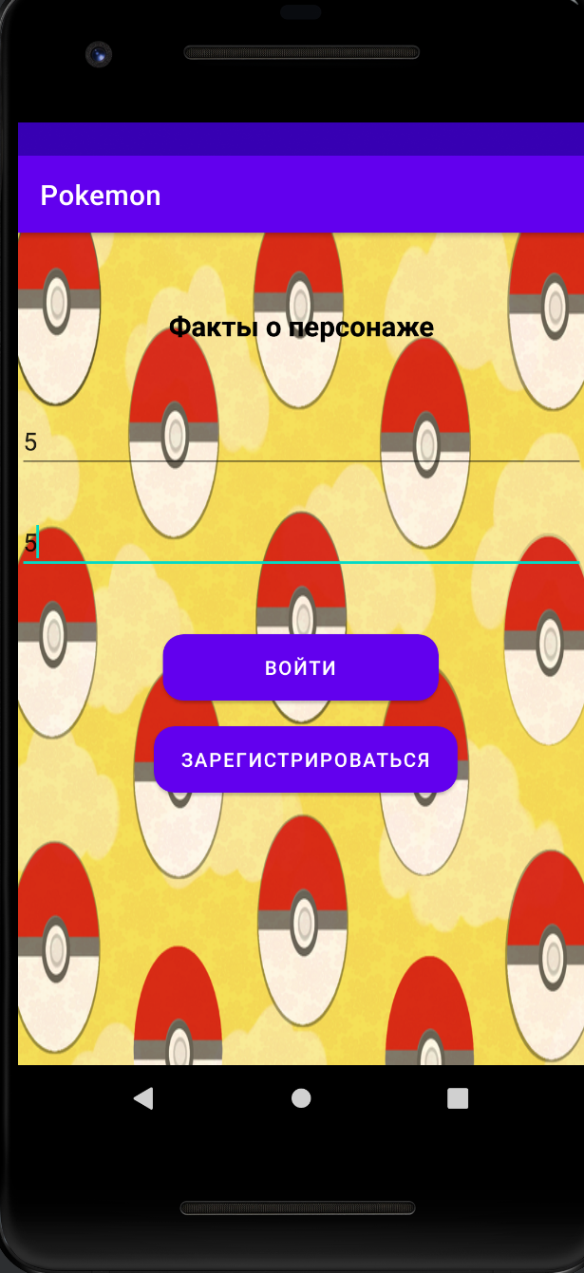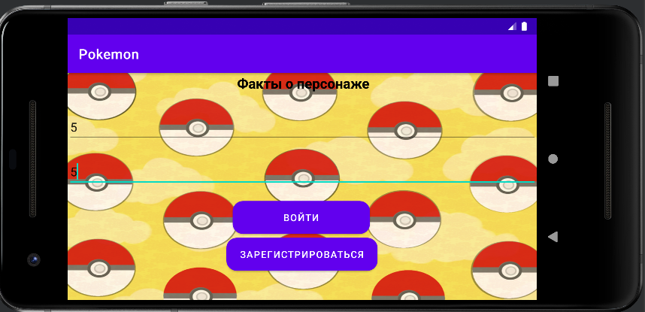

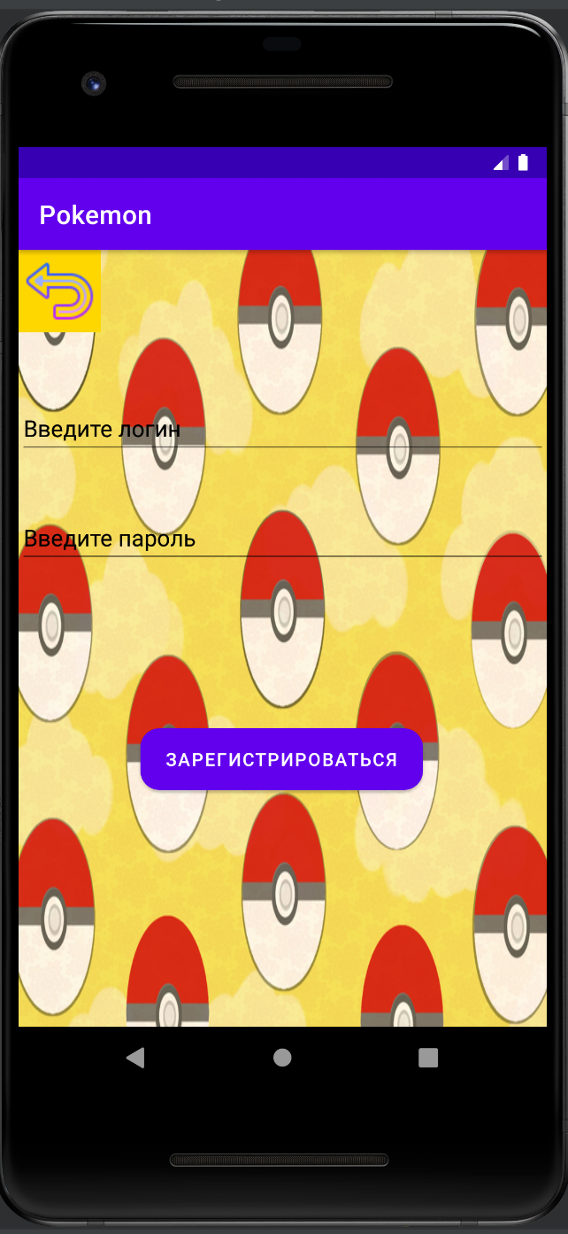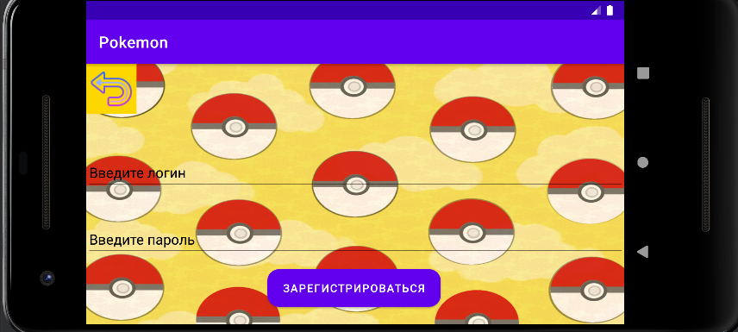

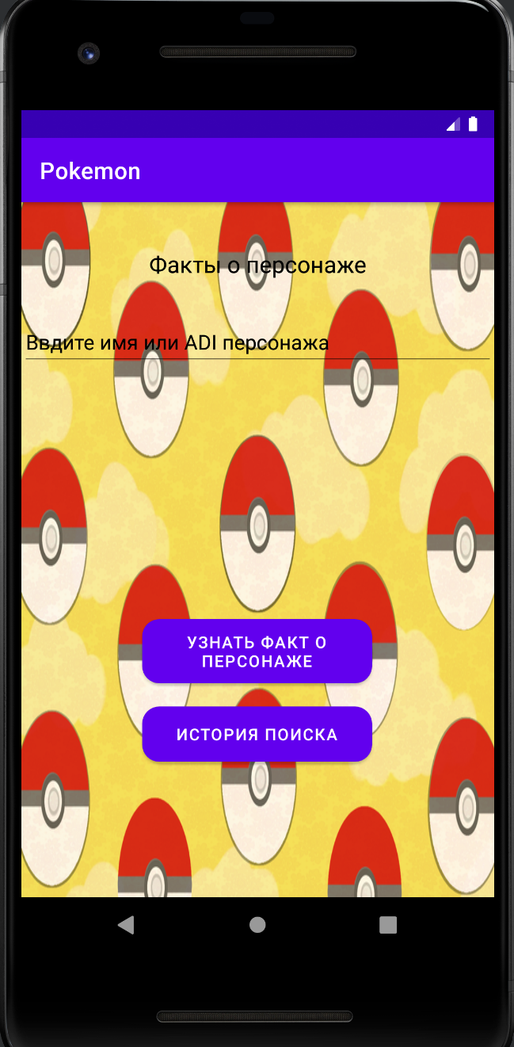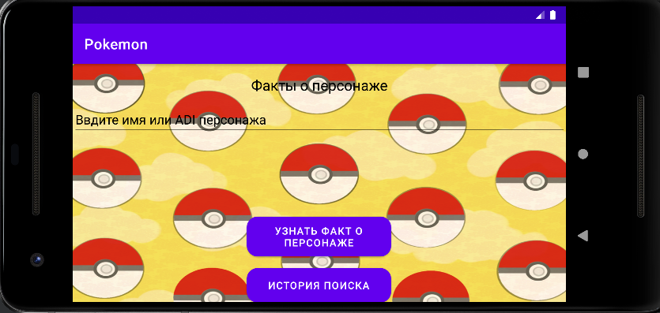

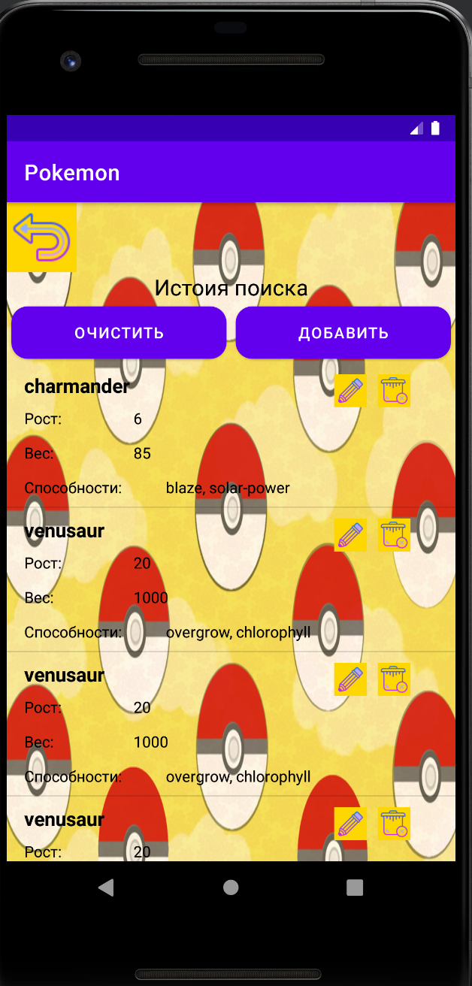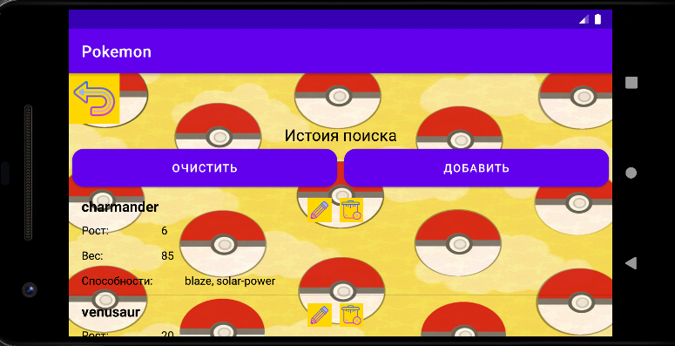

**Тестовые ситуации:**

Если пользователь не будет водить пароль и/или логин, то программа сообщит об ошибке

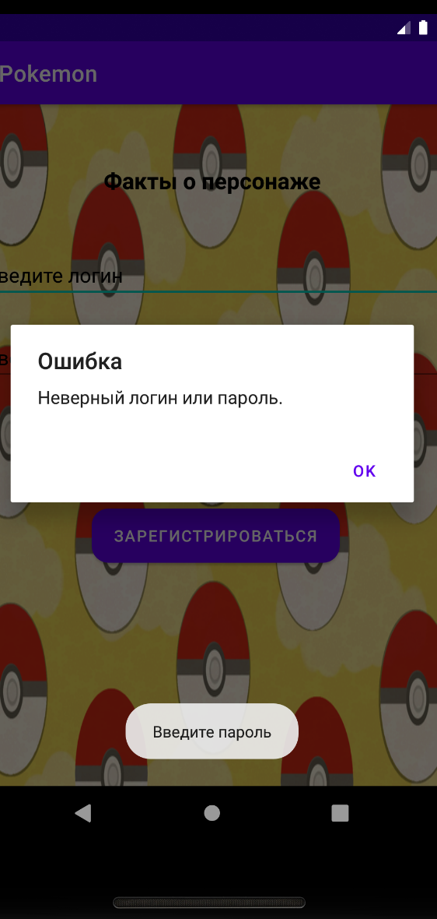

Если пользователь введет неверный пароль и/или логин то программа сообщит об ошибке

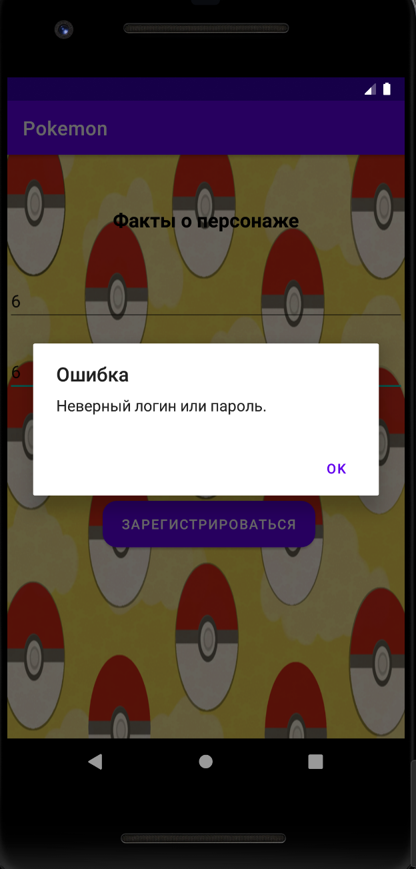

Если пользователь в режиме редактирование не заполнит поля то программа сообщит об этом

